CHAPTER 8: The dynamic Earth
Worksheet 8.5

Plotting earthquake activity
Answers
The following table contains data for large earthquakes that have occurred in the Pacific Rim in the
last 100 years.
 | Magnitude | Location | Latitude | Longitude
A | 8.5 | Kuril islands | 45°N | 150°E
B | 8.5 | Argentina | 29°S | 71°W
C | 8.5 | Banda Sea | 5°S | 132°E
D | 8.6 | Tibet | 29°N | 96°E
E | 8.6 | Indonesia | 2°N | 97°E
F | 8.8 | Ecuador (off coast) | 1°N | 82°W
G | 9.0 | Kamchatka | 53°N | 160°E
H | 9.1 | Sumatra | 3°N | 96°E
I | 9.2 | Alaska | 61°N | 148°W
J | 9.5 | Chile | 38°S | 73°W
1. Plot the location of each earthquake on the map below.
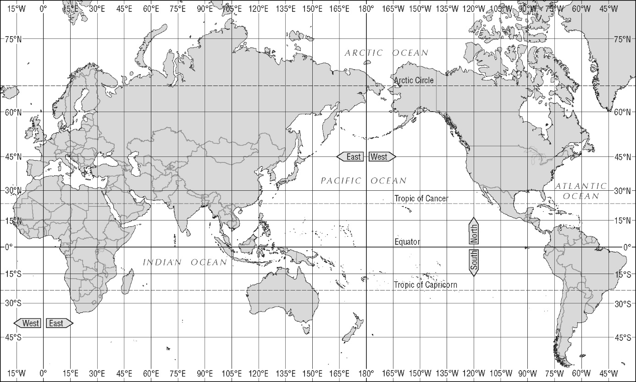
© MAPgraphics, Pty Ltd, Brisbane

CHAPTER 8: The dynamic Earth
Worksheet 8.5

Page 2

2. Account for the location of these earthquakes in relation to the tectonic plates.
Most of these earthquakes are along the Pacific Rim except for the Tibetan earthquake. The border of the Pacific represents the edges of the ocean plate and continental plates. These are zones of subduction, which lead to earthquakes and volcanic activity as the ocean plate is pushed below the continental plates. The Tibetan earthquake is the result of the Indo-Australian plate colliding with the Eurasian plate.

3. The Chilean earthquake occurred in 1960. What effect does an earthquake of this magnitude have on the ground surface?
An earthquake with a magnitude of 9.5 is catastrophic. The ground rises and falls during the event, resulting in complete devastation in the zone of the epicentre.

